Secure Coding Lab – 4

Dasari Mohan Amritesh

18BCN7038

**Write a python script to print hello world:**

print("Hello world")

x=input("Press Enter to exit:")



**Convert the script into executable (use pyinstaller or py2exe – any of your choice).:**

C:\Users\dmamr\Desktop\Secure lab temp>pyinstaller temp.py

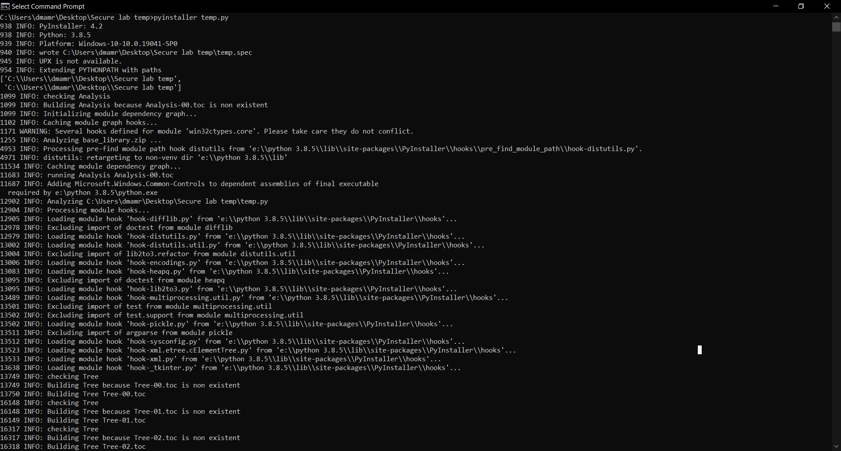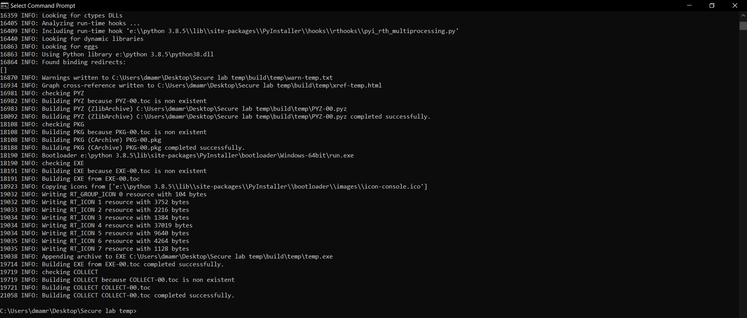

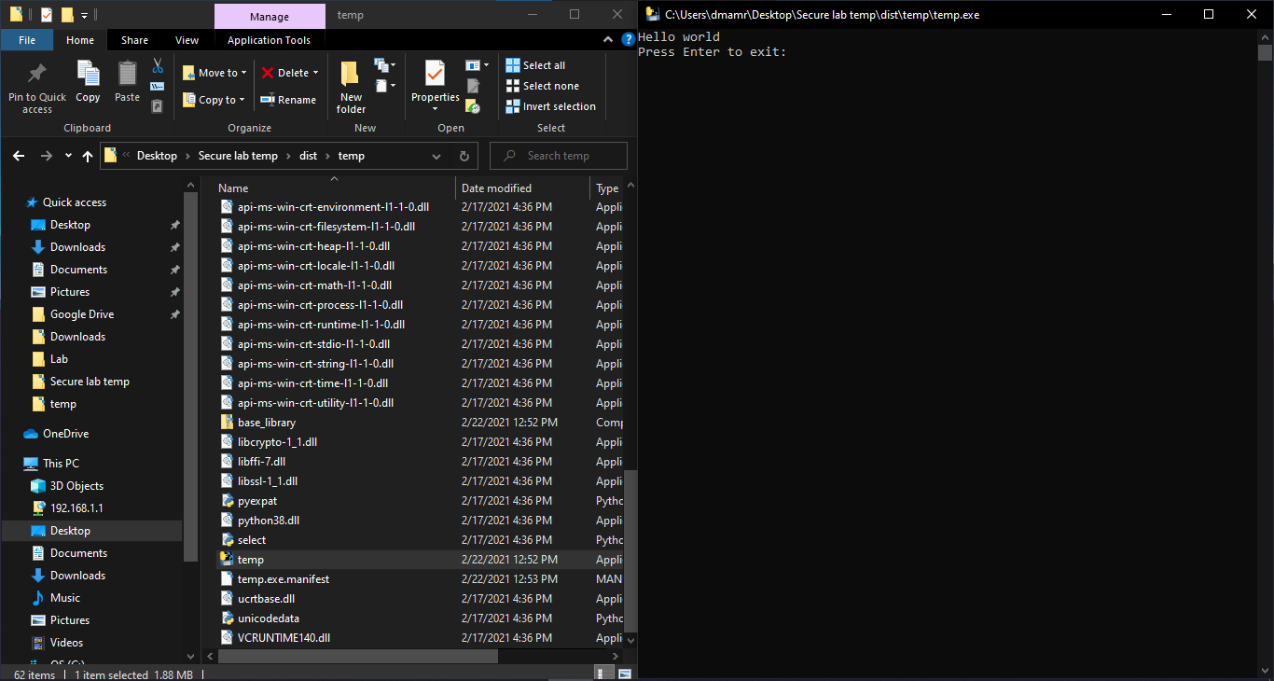

**Schedule a task named “Python execution" to run the above executable on the first Monday of every month.**

C:\Users\dmamr>schtasks /create /tn Python_Execution /tr "C:\Users\dmamr\Desktop\Secure lab temp\dist\temp\temp.exe" /sc weekly /mo 4 /d MON



**Schedule a task named “Executor" on your machine to run calculator for every five minutes starting from the specified start time with no end.**

C:\Users\dmamr>schtasks /create /tn executor /tr "calculator.exe" /sc minute /mo 5



**Schedule a task named “Executor2" to run notepad starting at 5:00PM and automatically terminating at 5:40PM hours every day.**

C:\Users\dmamr>schtasks /create /tn Executer2 /tr "notepad.exe" /sc daily /st 17:00 /et 17:40

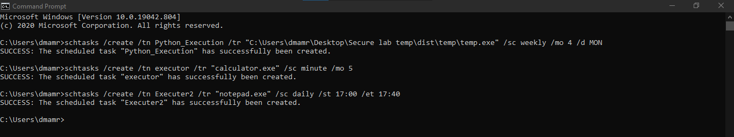

**Schedule a task to defragment any of your local disk daily at 10AM**

C:\Users\dmamr>schtasks /create /tn Executor3 /tr "defrag.exe C:" /sc daily /st 10:00

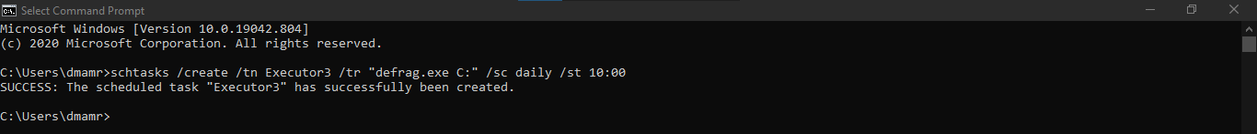

**PowerCFG:**

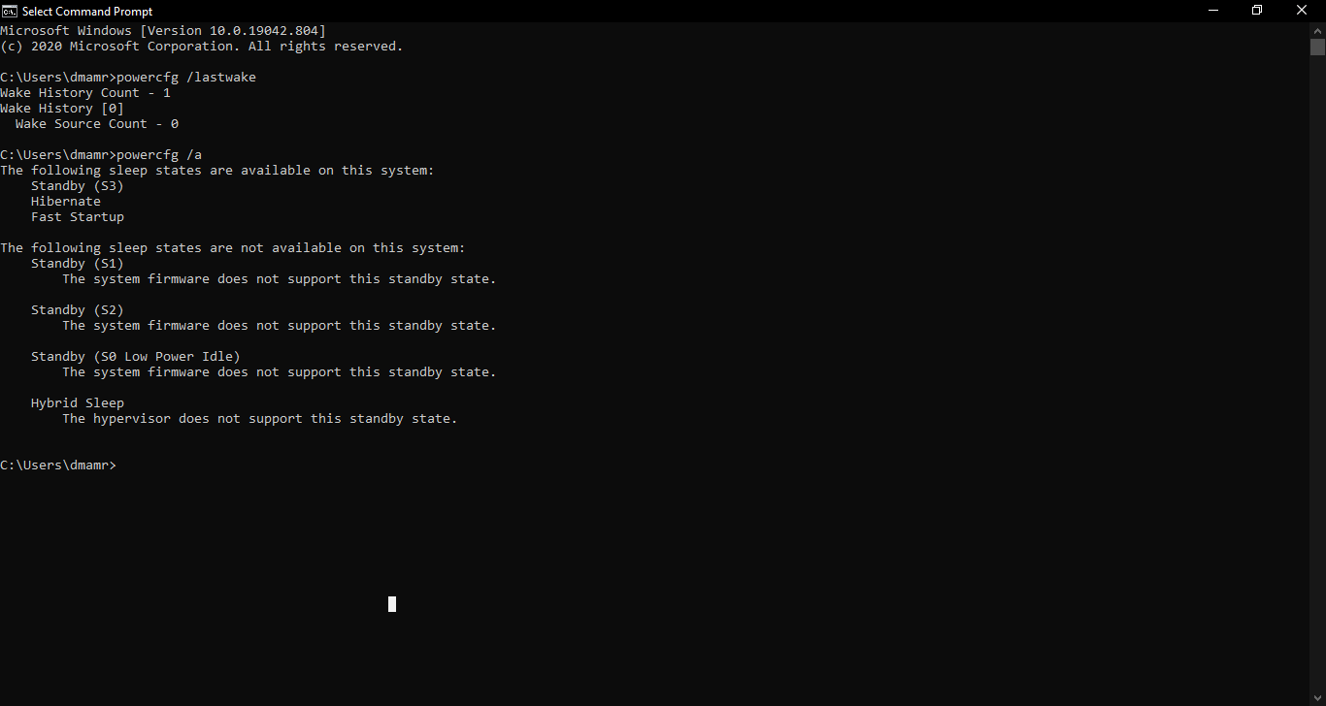

**Write a script to perform the following jobs:**

*To lock your windows PC (Windows+L):*

import ctypes

ctypes.windll.user32.LockWorkStation()

*To clear your Recycle Bin:*

import winshell

winshell.recycle_bin().empty(confirm=False, show_progress=False, sound=False)